

Meta 2.1
Ejemplo analizador léxico

Materia
Traductores (361)

Docente
Guillermo Licea Sandoval

Participante(es)
Luis Eduardo Galindo Amaya
1274895

15 de feb de 2025
Sumario
Instrucciones 3
Estado 4
Autómata 6
Main 9

Instrucciones
Adjunta un archivo con el código de tu analizador léxico basado en ER y AF.

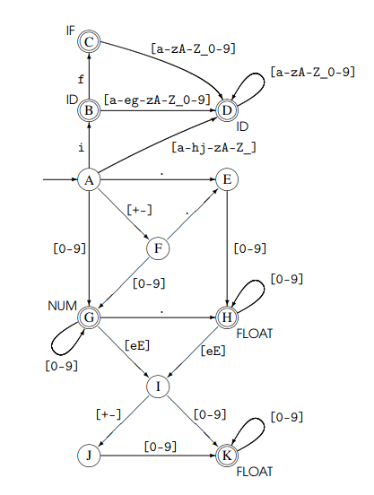

Estado
package Automaton2;

import java.util.HashMap;
import java.util.Map;
import java.util.regex.Matcher;
import java.util.regex.Pattern;

public class State {
private final Map<String, State> transitions = new HashMap<>();
private final boolean isFinal;
private final String tokenType;

public boolean isFinal() {
return isFinal;
}

public String getTokenType() {
return tokenType;
}

public State(boolean isFinal, String tokenType) {
this.isFinal = isFinal;
this.tokenType = tokenType;
}

public State addTransition(String condition, State state) {
transitions.put(condition, state);
return this;
}

public State nextState(String test) {

for (String regex : transitions.keySet()) {

Pattern pattern = Pattern.compile(regex);
Matcher matcher = pattern.matcher(test);

if (matcher.find()) {
// Retorna el estado del patron
return transitions.get(regex);
}
}

return null;
}

}

Autómata
package Automaton2;

public class Automaton {
State A = new State(false, "A");
State B = new State(true, "ID");
State C = new State(true, "IF");
State D = new State(true, "ID");

State E = new State(false, "E");
State F = new State(false, "F");
State G = new State(true, "NUM");

State H = new State(true, "FLOAT");
State I = new State(false, "I");
State J = new State(false, "J");
State K = new State(true, "FLOAT");

public Automaton() {

// Cargar los estados del automata
A.addTransition("i", B);
A.addTransition("[a-hj-zA-Z_]", D);
A.addTransition("[+-]", F);
A.addTransition("\\.", E);
A.addTransition("[0-9]", G);

B.addTransition("[a-eg-zA-Z_0-9]", D);
B.addTransition("f", C);

C.addTransition("[a-zA-Z_0-9]", D);

D.addTransition("[a-zA-Z_0-9]", D);

E.addTransition("[0-9]", H);

F.addTransition("[0-9]", G);
F.addTransition("\\.", E);

G.addTransition("[0-9]", G);
G.addTransition("\\.", H);
G.addTransition("e|E", I);

H.addTransition("[0-9]", H);
H.addTransition("e|E", I);

I.addTransition("[+-]", J);
I.addTransition("[0-9]", K);

J.addTransition("[0-9]", K);

K.addTransition("[0-9]", K);
}

public String tokenType(String input) {
State currentState = A;
int length = input.length();

if (input.isBlank()) {
throw new IllegalArgumentException("Entrada vacia");
}

for (int i = 0; i < length; i++) {
char c = input.charAt(i);
State nextState = currentState.nextState(c + "");

if (nextState == null) {
throw new IllegalArgumentException("Error de sintaxis");
}

if (!nextState.isFinal() && i == length - 1) {
throw new IllegalArgumentException("No se pudo llegar a un estado final");
}

currentState = nextState;
}

return currentState.getTokenType();
}

}

Main
package org.example;

import Automaton2.Automaton;
import java.util.stream.Stream;

public class Main {
public static void main(String[] args) {
Automaton automaton = new Automaton();

Stream<String> validInputs = Stream.of(
"iff", "123.", "if", "123.45", "abc123", "1.2e-3", "xyz", "IF"
);

Stream<String> invalidInputs = Stream.of(
"123#", "1abc", ".abc", "1.2.3", "1.2e", "1.2e+", "", "123e", "abc!", "1.2e3.4"
);

// Combinar los Streams
String[] combinedInputs = Stream.concat(validInputs, invalidInputs).toArray(String[]::new);

for (String input : combinedInputs) {
try {
System.out.println("Token: " + input + " -> " + automaton.tokenType(input));
} catch (RuntimeException e) {
System.err.println("Error en '" + input + "': " + e.getMessage());
}
}

}
}

Salida

